**HTML Assignments**

1. **Create a static webpage using table tags of HTML.**

<!DOCTYPE html>

<html lang="en">

<head>

    <meta charset="UTF-8">

    <meta name="viewport" content="width=device-width, initial-scale=1.0">

    <title>Static Webpage with Table</title>

</head>

<body>

    <h2 style="text-decoration: underline;">Employee Details</h2>

    <table border = "4" cellpadding = "5" cellspacing = "5" style="border-color: cadetblue; box-shadow: 3px 3px 3px gray;">

        <header>

            <tr>

                <td colspan="4" style="background-color: rgb(255, 191, 0); text-align: center; font-weight: bold;">This is the heading of this table</td>

            </tr>

        </header>

        <tr style="background-color: greenyellow;">

            <th>ID</th>

            <th>Name</th>

            <th>Department</th>

            <th>Salary</th>

        </tr>

        <tr style="background-color: yellow;">

            <td>101</td>

            <td>John Doe</td>

            <td>IT</td>

            <td>$5000</td>

        </tr>

        <tr style="background-color: yellow;">

            <td>102</td>

            <td>Jane Smith</td>

            <td>HR</td>

            <td>$4500</td>

        </tr>

        <tr style="background-color: yellow;">

            <td>103</td>

            <td>Sam Wilson</td>

            <td>Finance</td>

            <td>$5500</td>

        </tr>

        <tr style="background-color: rgb(0, 238, 255); color: brown;">

            <td colspan="3">Total Salary</td>

            <td>$15000</td>

        </tr>

        <footer>

            <tr>

                <td colspan="4" style="font-family: 'Lucida Sans', 'Lucida Sans Regular', 'Lucida Grande', 'Lucida Sans Unicode', Geneva, Verdana, sans-serif; text-align: center; background-color: rgb(215, 182, 97);">This is the footer of this table</td>

            </tr>

        </footer>

    </table>

</body>

</html>

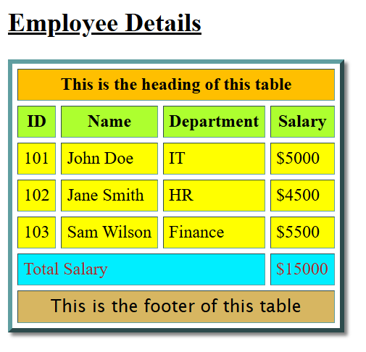

1. **Create a static web page which defines all text formatting tags of HTML in tabular format.**

<!DOCTYPE html>

<html lang="en">

<head>

    <meta charset="UTF-8">

    <meta name="viewport" content="width=device-width, initial-scale=1.0">

    <title>HTML Text Formatting Tags</title>

</head>

<body>

    <h2 style="text-decoration: underline;">HTML Text Formatting Tags</h2>

    <table border = "4" cellpadding = "5" cellspacing = "5" style="border-color: cadetblue; box-shadow: 3px 3px 3px gray;">

        <tr>

            <th>Tag</th>

            <th>Description</th>

            <th>Example</th>

        </tr>

        <tr>

            <td>&lt;b&gt;</td>

            <td>Bold Text</td>

            <td><b>Bold</b></td>

        </tr>

        <tr>

            <td>&lt;i&gt;</td>

            <td>Italic Text</td>

            <td><i>Italic</i></td>

        </tr>

        <tr>

            <td>&lt;u&gt;</td>

            <td>Underlined Text</td>

            <td><u>Underlined</u></td>

        </tr>

        <tr>

            <td>&lt;small&gt;</td>

            <td>Small Text</td>

            <td><small>Small</small></td>

        </tr>

        <tr>

            <td>&lt;mark&gt;</td>

            <td>Highlighted Text</td>

            <td><mark>Highlighted</mark></td>

        </tr>

        <tr>

            <td>&lt;del&gt;</td>

            <td>Deleted Text</td>

            <td><del>Deleted</del></td>

        </tr>

        <tr>

            <td>&lt;sup&gt;</td>

            <td>Superscript Text</td>

            <td>2<sup>nd</sup></td>

        </tr>

        <tr>

            <td>&lt;sub&gt;</td>

            <td>Subscript Text</td>

            <td>H<sub>2</sub>O</td>

        </tr>

        <tr>

            <td>&lt;code&gt;</td>

            <td>Monospaced Code</td>

            <td><code>print("Hello World")</code></td>

        </tr>

        <tr>

            <td>&lt;blockquote&gt;</td>

            <td>Block Quotation</td>

            <td><blockquote>Quote</blockquote></td>

        </tr>

    </table>

</body>

</html>

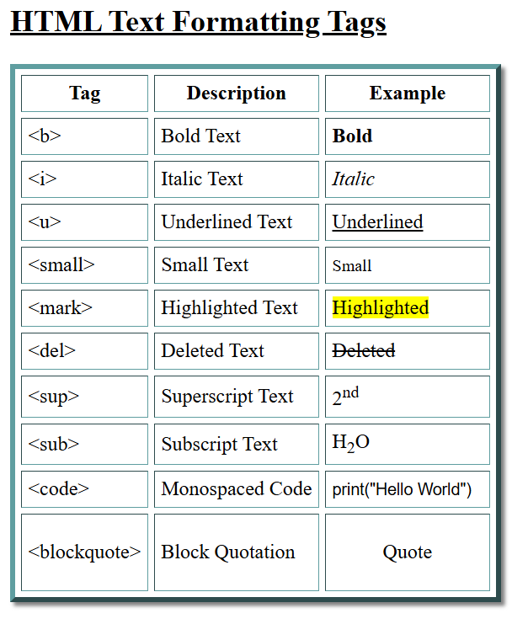

1. **Create a webpage using list tags of HTML.**

<!DOCTYPE html>

<html lang="en">

<head>

    <meta charset="UTF-8">

    <meta name="viewport" content="width=device-width, initial-scale=1.0">

    <title>HTML List Tags</title>

</head>

<body>

    <h2 style="text-decoration: underline;

    text-shadow: 7px 3px 7px #669abc;">HTML List Tags</h2>

    <h3>Unordered List</h3>

    <ul style="list-style: lower-roman;">

        <li>Item 1</li>

        <li>Item 2</li>

        <li>Item 3</li>

        <li>Item 4</li>

    </ul>

    <h3>Ordered List</h3>

    <ol>

        <li>First Item</li>

        <li>Second Item</li>

        <li>Third Item</li>

        <li>Fourth Item</li>

    </ol>

    <h3>Nested List</h3>

    <ul>

        <li>Category 1

            <ul>

                <li>Subitem 1</li>

                <li>Subitem 2</li>

            </ul>

        </li>

        <li>Category 2

            <ul>

                <li>Subitem A</li>

                <li>Subitem B</li>

            </ul>

        </li>

    </ul>

</body>

</html>

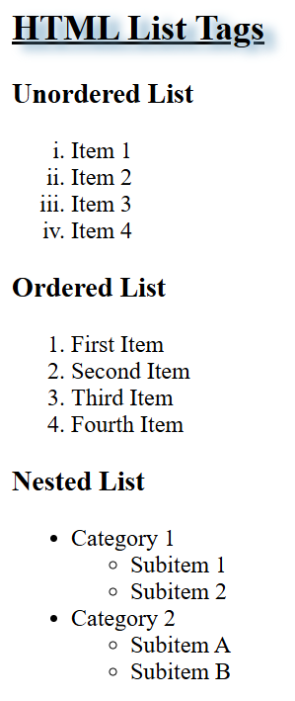

1. **Create webpage to include image using HTML tag.**

<!DOCTYPE html>

<html lang="en">

<head>

    <meta charset="UTF-8">

    <meta name="viewport" content="width=device-width, initial-scale=1.0">

    <title>HTML Image Tag</title>

</head>

<body>

    <h2 style="margin: 0; padding: 0;">Displaying an Image in HTML</h2>

    <img src="https://images.pexels.com/photos/268533/pexels-photo-268533.jpeg?auto=compress&cs=tinysrgb&w=1260&h=750&dpr=2" alt="Sample Image" style="height: 90vh; width: 74vw; margin: 5px; box-shadow: 7px 5px 5px rgba(0, 0, 0, 0.2); border-radius: 10px;">

</body>

</html>

